Egyptian Ministry of Education

🔹 Definition
# Source: ScreenShots Source: Provided by: [Persons Table -> ID Column: 1, Name_En Column: Motasem Essam] -> Tool: [Lightshot Program] -> From [Site: https://moe.gov.eg/] on [11/15/2025]
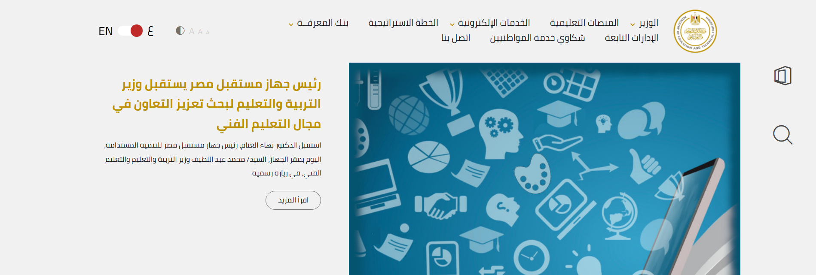
# Source: AI Source: Provided by: [Data Path: Persons Table -> ID Column: 1, Name_En Column: Motasem Essam] -> From: [ChatGPT] on [11/15/2025]
Egyptian Ministry of Education - moe.gov.eg is the official website of the Ministry of Education (MoE) of Egypt (in Arabic: وزارة التربية والتعليم). (Ministry of Education Egypt)
Here’s what it’s for and what you can find on it:
- It’s the government portal for Egypt’s Ministry of Education, responsible for K-12 education, schools, teaching policy, and more. (Wikipedia)
- Provides news and updates about the education system in Egypt, like minister decisions, school projects, and educational reforms. (Ministry of Education Egypt)
- Offers e-learning platforms and links to educational resources — including portals for students and teachers. (Ministry of Education Egypt)
- Contains electronic services for students and parents (e.g., digital assessments, exam information). (خليجي سفن)
- Provides information specifically for teachers, including professional development, training, and teacher portals. (Ministry of Education Egypt)

🎯 Purpose
# Source: AI Source: Provided by: [Data Path: Persons Table -> ID Column: 1, Name_En Column: Motasem Essam] -> From: [ChatGPT] on [11/15/2025]
- To act as the central online hub for all educational policies, services, and resources in Egypt.
- To support digital transformation in education, making key educational services accessible online.
- To communicate with students, parents, and teachers about national education initiatives, school performance, and educational news.

🛡️ Safety & Legality
# Source: AI Source: Provided by: [Data Path: Persons Table -> ID Column: 1, Name_En Column: Motasem Essam] -> From: [ChatGPT] on [11/15/2025]
- This is an official government site, so it is completely legal and safe.
- It does not distribute pirated or copyrighted material improperly — rather, it provides public services.
- Users (students, parents, teachers) can rely on it as an authoritative and trustworthy source for education information in Egypt.

📌 Summary
# Source: AI Source: Provided by: [Data Path: Persons Table -> ID Column: 1, Name_En Column: Motasem Essam] -> From: [ChatGPT] on [11/15/2025]
The Ministry of Education (MoE) of Egypt website is the official government portal providing information, news, and services related to K–12 education in Egypt. It offers resources for students, parents, and teachers, including digital platforms for exams, e-learning, professional development, and educational updates. The site serves as a central hub for educational policy, communication, and online services. Being an official government site, it is safe, legal, and authoritative.

